**Project Name – Moodle**

**By – Anubha Barve**

[**barveanubha2510@gmail.com**](mailto:barveanubha2510@gmail.com)

Aim of the project –

**Moodle** is an open source learning platform which provides educators, administrators, and learners with a single robust, secure, and integrated system to create personalized learning environments.

Project evaluation –

|  |  |  |
| --- | --- | --- |
| Evaluation Criteria | Level (0-2) | Evaluation Data |
| License | 2 | <https://github.com/moodle>  Uses GNU General Public License v3.0  Link - <https://github.com/moodle/moodle/blob/master/COPYING.txt> |
| Technology | 2 | **The top three languages used and the percentage for each.**  Languages used:  PHP – 77%  Javascript – 16%  CSS – 2.1%  HTML – 1.8%  Gherkin – 3.1%  Familiar with above technologies |
| Level of Activity | 2 | Remained active over last one year  Link - <https://github.com/moodle/moodle/graphs/commit-activity> |
| Number of Contributors | 2 | **Number of contributors to the OpenMRS core project**  497 direct contributors are there for the project |
| Product Size | 2 | 532.02 MB is the size of project |
| Issue Tracker | 2 | Has a separate tracker for issues and bugs.  Link - <https://tracker.moodle.org/secure/Dashboard.jspa> |
| New Contributor | 2 | Instructions for downloading and installing the development environment are provided on the Moodle website with step by step installation guide and details regarding development environment  Links - <https://docs.moodle.org/38/en/Manual_install_on_Windows_7_with_Apache_and_MySQL>  <https://docs.moodle.org/dev/Main_Page>  <https://docs.moodle.org/dev/Git_for_developers#Installing_Git_on_your_computer>  <https://docs.moodle.org/38/en/Installing_Moodle>  Moodle developers use Telegram for communication  <https://telegram.me/moodledev>  Moodle has a discussion forum where support is provided for installation queries or issues.  Link –  <https://moodle.org/mod/forum/view.php?id=8657> |
| Community Norms | 2 | Moodle has a code of conduct which is present in the documentation  <https://docs.moodle.org/22/en/Moodle.org_forums_Code_of_Conduct>  Also, the telegram chatroom of developers has a message pinned at the top which mentions how the contributors are expected to behave in the chatroom. |
| User Base | 2 | Moodle has got an active user base in various countries.  <https://moodleassociation.org/> |
| **Total Score** | 18 |  |

Walked through the Moodle demo - <https://moodle.org/demo>

Read the following documentations –

* Overview - <https://docs.moodle.org/dev/Overview>
* Development Process - <https://docs.moodle.org/dev/Process>
* Git For Developers - <https://docs.moodle.org/dev/Git_for_developers>
* Core APIs - <https://docs.moodle.org/dev/Core_APIs>
* Tracker Guide - <https://docs.moodle.org/dev/Tracker_guide>
* Development Environment Set up - <https://docs.moodle.org/dev/Setting_up_development_environment>

Moodle Installation required following software installations –

* PHP 7.0
* MySQL 5.7.0
* Git
* Apache 2.4

Git Installation –

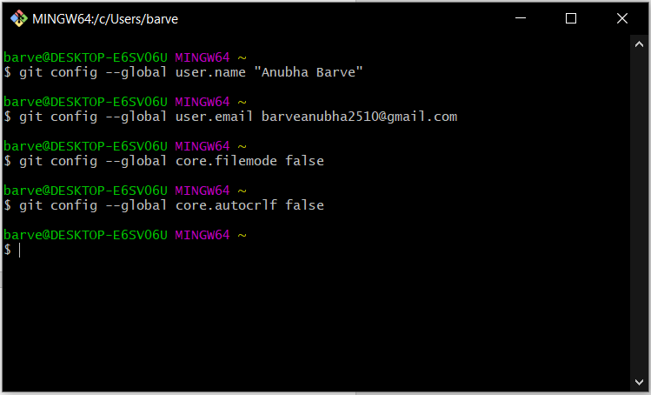

Resolved Database connection error.

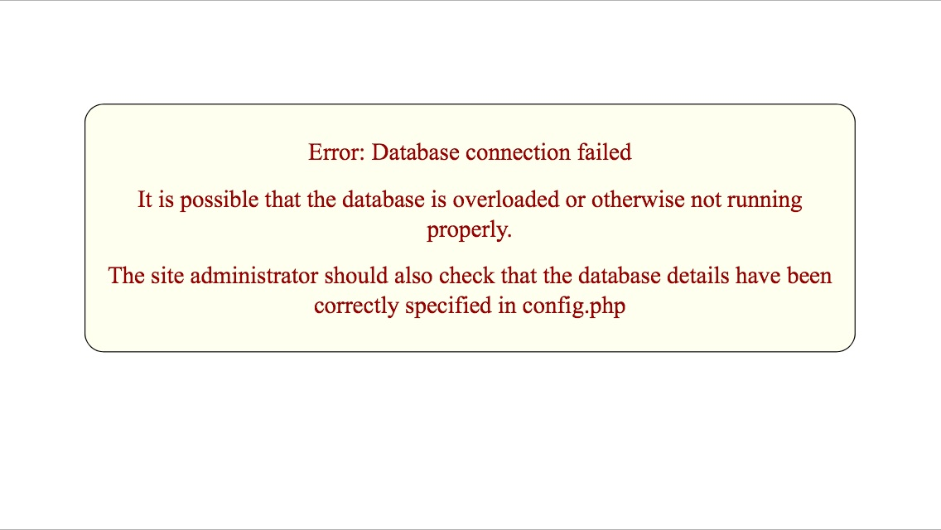

Created account on Moodle Tracker – to report an issue or suggest a new idea an account is required on the tracker.